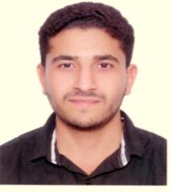**Objective**

To utilize my technical skills for achieving the target and developing the best performance in the organization. I would like to implement my innovative ideas, skills and creativity for accomplishing the projects.

**Personal Information**

**Name:** MOHAMMED ALI MAKKI SAHWAN   
**Date of Birth:** NOVEMBER.11.1988   
**Nationality:** BAHRAINI  
**Mobile:** +973/ 37129607 , 39551355 , 33981346  
**E-mail:** [mohammedali1988@hotmail.co.uk](mailto:mohammedali1988@hotmail.co.uk)

**Experience**

* 2015 - present , **Technical Supervisor IT** : Abu Ammar Stationery **Part time**
* 2011 - present, **technical site supervisor**: ALMOAYYED CONTRACTING GROUP **Full time**

**Education ( engineering collage )**

* **B.S in Informatics Engineering : Computer & Network engineer**  AMA University , **2013 - 2018**
* **Higher National Diploma in Mechanical Engineering** – Bahrain Training Institute, **2007 - 2013**
* **Secondary School Certificate – refrigeration and air conditioning** Al-Jabiri**a** Secondary School**, 2003 - 2006**

**Professional Courses (license)**

* **Supervisory skills**
* **CCNA Security** Routing & Switching
* **CCNA :** Routing & Switching

**Skills**

* **Computer Skills:** MS Office Windows, Auto Cad, Photoshop, , MatLAB, , SQL(database) , packet tracer , C++ , Java , control system

**Language:**

* **Arabic:** Native **>>** **English:** good